NurdleDNA: An Edge-AI and IoT Inline System for Source-Level Microplastic Detection
Faaz Ali Sayyed  Computer and Autonomous Systems Engineering  University of Wollongong in Dubai  Dubai, United Arab Emirates  fasas305@uowmail.edu.au | Muhammad Haaziq  Computer and Autonomous Systems Engineering  University of Wollongong in Dubai  Dubai, United Arab Emirates  mh084@uowmail.edu.au | Daniel Joseph Koshy  Computer and Autonomous Systems Engineering  University of Wollongong in Dubai  Dubai, United Arab Emirates  djk545@uowmail.edu.au
Mohammed Abdul Rehman  Computer and Autonomous Systems Engineering  University of Wollongong in Dubai  Dubai, United Arab Emirates  mar699@uowmail.edu.au | Syed Hasan Ali  Computer and Autonomous Systems Engineering  University of Wollongong in Dubai  Dubai, United Arab Emirates  sha245@uowmail.edu.au

Abstract—Industrial coastal water infrastructure requires rapid pollution interception before microplastic contamination leaves controlled discharge pathways and enters marine ecosystems. Pre-production plastic pellets (nurdles) are difficult to manage because they are small, highly mobile, visually similar to other suspended particles, and handled in large quantities across petrochemical plants, ports, and industrial drainage networks. Conventional approaches — manual inspection, passive filtration, turbidity sensing, and laboratory FTIR or Raman analysis — either lack real-time capability or fail to provide source-level containment. This paper introduces NurdleDNA, an edge-AI and IoT-enabled inline system for real-time microplastic detection, automated flow isolation, physical evidence capture, and cloud-based compliance logging. The architecture integrates an optical vision chamber, YOLO-based detection, turbidity verification, VOC/gas sensing, load-cell capture measurement, servo-actuated valve isolation, and a cloud audit dashboard within a closed-loop detect–classify–actuate–capture–report framework. Prototype-level validation demonstrates rapid contamination recognition, automatic valve response, evidence capture, and time-stamped event logging for scalable deployment in industrial water channels.
Keywords—microplastic detection, nurdles, edge AI, Internet of Things, industrial water monitoring, source-level containment, multi-sensor fusion, cloud audit logging.
I. Introduction
Plastic pellet pollution, specifically from pre-production pellets known as nurdles, has emerged as a critical global threat to marine and coastal ecosystems. Due to their small size (3–5 mm) and high mobility, these pellets are easily transported by winds and ocean currents, accumulating in ecological hotspots and acting as vectors for toxic chemical contaminants when ingested by marine life [9]. Tracing these pollutants back to their industrial sources remains a major challenge due to their apparent physical homogeneity.
To resolve this, we propose the concept of “Nurdle DNA”, a multi-dimensional physical and chemical fingerprint unique to individual pellet batches and their environmental histories. Decoding this signature requires a combination of high-throughput optical and spectroscopic techniques: portable Raman spectroscopy for primary polymer identification and surface weathering [9], visible–near-infrared (VIS-NIR) spectroscopy combined with chemometric machine learning such as 1D-CNNs and partial least squares regression for complex mixtures [10], and state-of-the-art computer vision object detection (YOLOv8, RetinaNet, Faster R-CNN) for automated physical classification at industrial scale [11]. Integrated, these techniques establish a framework for tracking spill origins, assessing marine residence times, and optimising coastal monitoring.
II. Literature Review
A. Microplastic and Nurdle Pollution in Industrial Water Systems
Microplastics — plastic particles smaller than 5 mm — persist in water systems, fragment further, and may enter food chains [1]. Studies from Dubai and the wider MENA region confirm the need for coastal and industrial microplastic monitoring [2], [3]. Pre-production nurdles are a major source-level risk because they leak from polymer plants, ports, and logistics areas into drains and coastal waters. NurdleDNA addresses this gap through an inline IoT system that detects nurdles, isolates contaminated flow, captures evidence, and logs events to the cloud.
B. Climate, Ecosystem, and Environmental Damage
Microplastic pollution affects ecosystems, biodiversity, and climate resilience. UNEP reports that plastic pollution alters habitats and natural processes, reducing ecosystem resilience to climate change [4]. In marine environments, microplastics affect ocean health and reduce the ocean’s capacity to support carbon sequestration, which is important for climate regulation [5]. Preventing nurdle leakage at the industrial source is therefore more effective than recovering plastics after environmental dispersion.
C. Limitations of Existing Monitoring Approaches
Current detection methods are limited for real-time industrial prevention. Manual inspection is slow, filters can clog, and laboratory methods such as FTIR, Raman, and microscopy require offline sampling and specialised equipment [6]. Turbidity sensors and particle counters can detect abnormalities but cannot reliably classify nurdles from bubbles, sand, or biological particles. This creates a clear need for a system that can detect and stop contamination in real time.
D. Edge-AI, Multi-Sensor Fusion, and IoT Monitoring
Edge AI and IoT sensing provide a practical pathway for real-time microplastic monitoring. YOLO-based vision detects objects with bounding boxes, class labels, and confidence scores [7], while NVIDIA Jetson platforms support local AI inference without full cloud dependence [8]. NurdleDNA combines AI vision, turbidity sensing, VOC/gas detection, load-cell measurement, Arduino control, and cloud logging to support reliable multi-sensor environmental monitoring.
III. Methodology
A. System Architecture and Physical Partitioning
The NurdleDNA prototype uses a dual-layer containment model designed in Autodesk Fusion 360 [12], isolating liquid-conveying pathways from processing electronics. The
wet path (sensor zone) comprises a transparent inline optical flow cell with a WS2812B-8 LED strip providing uniform backlighting and an opposing camera viewport. A light-dependent resistor (LDR) inside the optical path serves as a turbidity sensor. An MQ-135 gas sensor in the headspace detects volatile organic compounds (VOCs). A downstream evidence cartridge is suspended from a load cell, and an upstream MG996R servo-actuated pinch valve governs flow isolation. The dry path (electronics zone) houses an NVIDIA Jetson Nano hosting the CNN inference engine and cloud publisher [13], and an Arduino Uno running the deterministic control logic. The two layers are physically partitioned so that water leaks cannot reach electronics and so a technician can swap sensors without touching the compute hardware.
[ INSERT FIG. 1 — CAD model ]
Fusion 360 isometric of the NurdleDNA prototype, showing the electronics enclosure mounted above the inline cylindrical flow conduit.
Fig. 1. CAD model of the NurdleDNA prototype showing the electronics enclosure mounted above the inline cylindrical flow conduit.
B. Multi-Sensor Acquisition and Signal Conditioning
Signal conditioning and telemetry are handled by the Arduino Uno at a 5 Hz sampling rate. Optoelectronic turbidity is read on pin A0; values exceeding Vₒ > 600 (warning threshold) flag potential contamination. Volatile petrochemical hydrocarbons are monitored on pin A1 via the MQ-135; ADC values above 200 trigger a critical alarm. Gravimetric accumulation in the downstream cartridge is measured using a parallel-beam load cell interfaced with a 24-bit HX711 converter (pins D4 and D10), calibrated with set_scale() to resolve spill mass in grams.
C. Edge Computer Vision and Classification Pipeline
Real-time visual monitoring uses a hybrid pipeline on the Jetson Nano balancing deep-learning classification with classical safety nets [12]. A YOLOv8n model (2.6 M parameters) was trained for 25 epochs on a T4 GPU using the Roboflow microplastics-t0ddd v6 dataset (3,102 images, 19 classes) [14]. The trained model was exported to ONNX and executed via onnxruntime, reducing runtime memory from 1.0 GB to ~100 MB while sustaining >5 FPS on the Jetson Nano CPU. In parallel, a classical HSV colour-thresholding and contour-analysis algorithm runs on the central frame as a safety net for bright rounded geometries that fall below the YOLO confidence threshold.
Four filtering layers suppress false positives: (1) a region-of-interest mask restricting detection to the central 60% of the frame; (2) a circularity filter (4πA/P²) rejecting linear highlights; (3) an exponential moving average (α = 0.20) smoothing per-frame counts; and (4) confirmation timers requiring warning (S2) and alarm (S3) states to persist for 1.5 s and 2.5 s respectively before transitioning.
D. Deterministic Finite State Machine Control Logic
Industrial safety mandates deterministic actuation decoupled from probabilistic AI inference. Control is managed by a 5-state Moore FSM executed on the Arduino Uno [15]. S0 (INIT) is the boot state and holds the pinch valve OPEN. S1 (SysOK) is normal operation (green LED, valve OPEN). S2 (Caution/WARN) is triggered by LDR > 600 OR AI detection count ≥ 4 sustained for ≥ 1.5 s (yellow LED). S3 (ALARM/CRIT) is triggered by MQ-135 > 200 OR AI count ≥ 12 sustained for ≥ 2.5 s — the red LED and buzzer activate, and the servo pinch valve closes within ~300 ms. S3 is physically latched and is cleared only via S4 (RSTIN) through the reset button on pin D2. Telemetry between the Jetson Nano and Arduino Uno is exchanged at 5 Hz over a 115,200 baud USB serial link in JSON format.
E. Cloud Telemetry and Remote Monitoring Interface
Remote monitoring is supported via Firebase Realtime Database. The Jetson Nano streams sensor telemetry at 5 Hz; video frames are downsampled to 320×240 pixels, JPEG-encoded at 60% quality, base64-encoded, and uploaded at 1 Hz to the operator web dashboard. On entering the S3 ALARM state, an immutable audit event containing the UTC timestamp, sensor values, and per-class detection counts is pushed to the database to establish a regulatory compliance log.
IV. Results and Discussion
Each stage of the closed-loop detect–classify–actuate–capture–report pipeline is evaluated below. The overall system architecture and physical partitioning are summarised in Fig. 2.
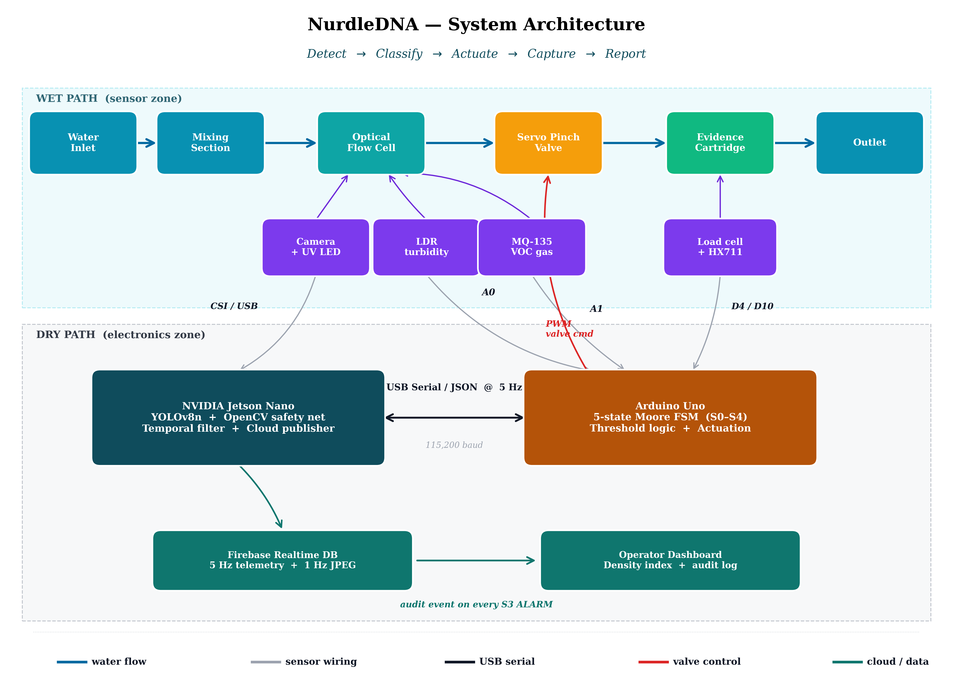
Fig. 2. System architecture showing the wet path (inline water flow with optical, gas, and gravimetric sensing) and the dry path (NVIDIA Jetson Nano running the YOLOv8n + OpenCV pipeline, Arduino Uno running the FSM, and the Firebase-backed audit dashboard).
A. Detection Accuracy of the Edge Vision Pipeline
The YOLOv8n model achieved mean Average Precision at IoU 0.50 (mAP@50) of 0.81 for synthetic pens, 0.75 for air bubbles, and 0.60 for fragments. The higher precision on pens and bubbles reflects their consistent geometric structure; fragments suffer from intra-class shape variability and visual overlap with biological debris. This skew is consistent with prior reports on YOLO-family models applied to microplastic imagery [12]. The bubble class result is operationally important: bubbles are the dominant source of optical false positives in inline flow cells, and reliable bubble labelling enables downstream filtering rather than confusion with true nurdles. The classical OpenCV HSV–contour safety net contributes redundancy when the deep model falls below threshold.
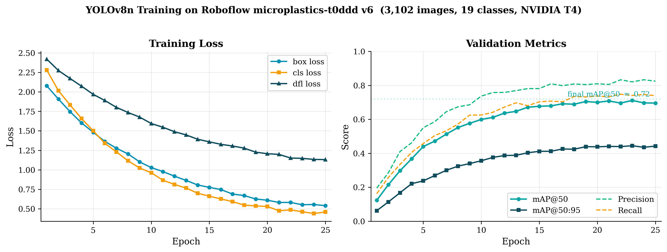
Fig. 3. YOLOv8n training loss and validation metrics over 25 epochs on the Roboflow microplastics-t0ddd v6 dataset; final mAP@50 ≈ 0.72.
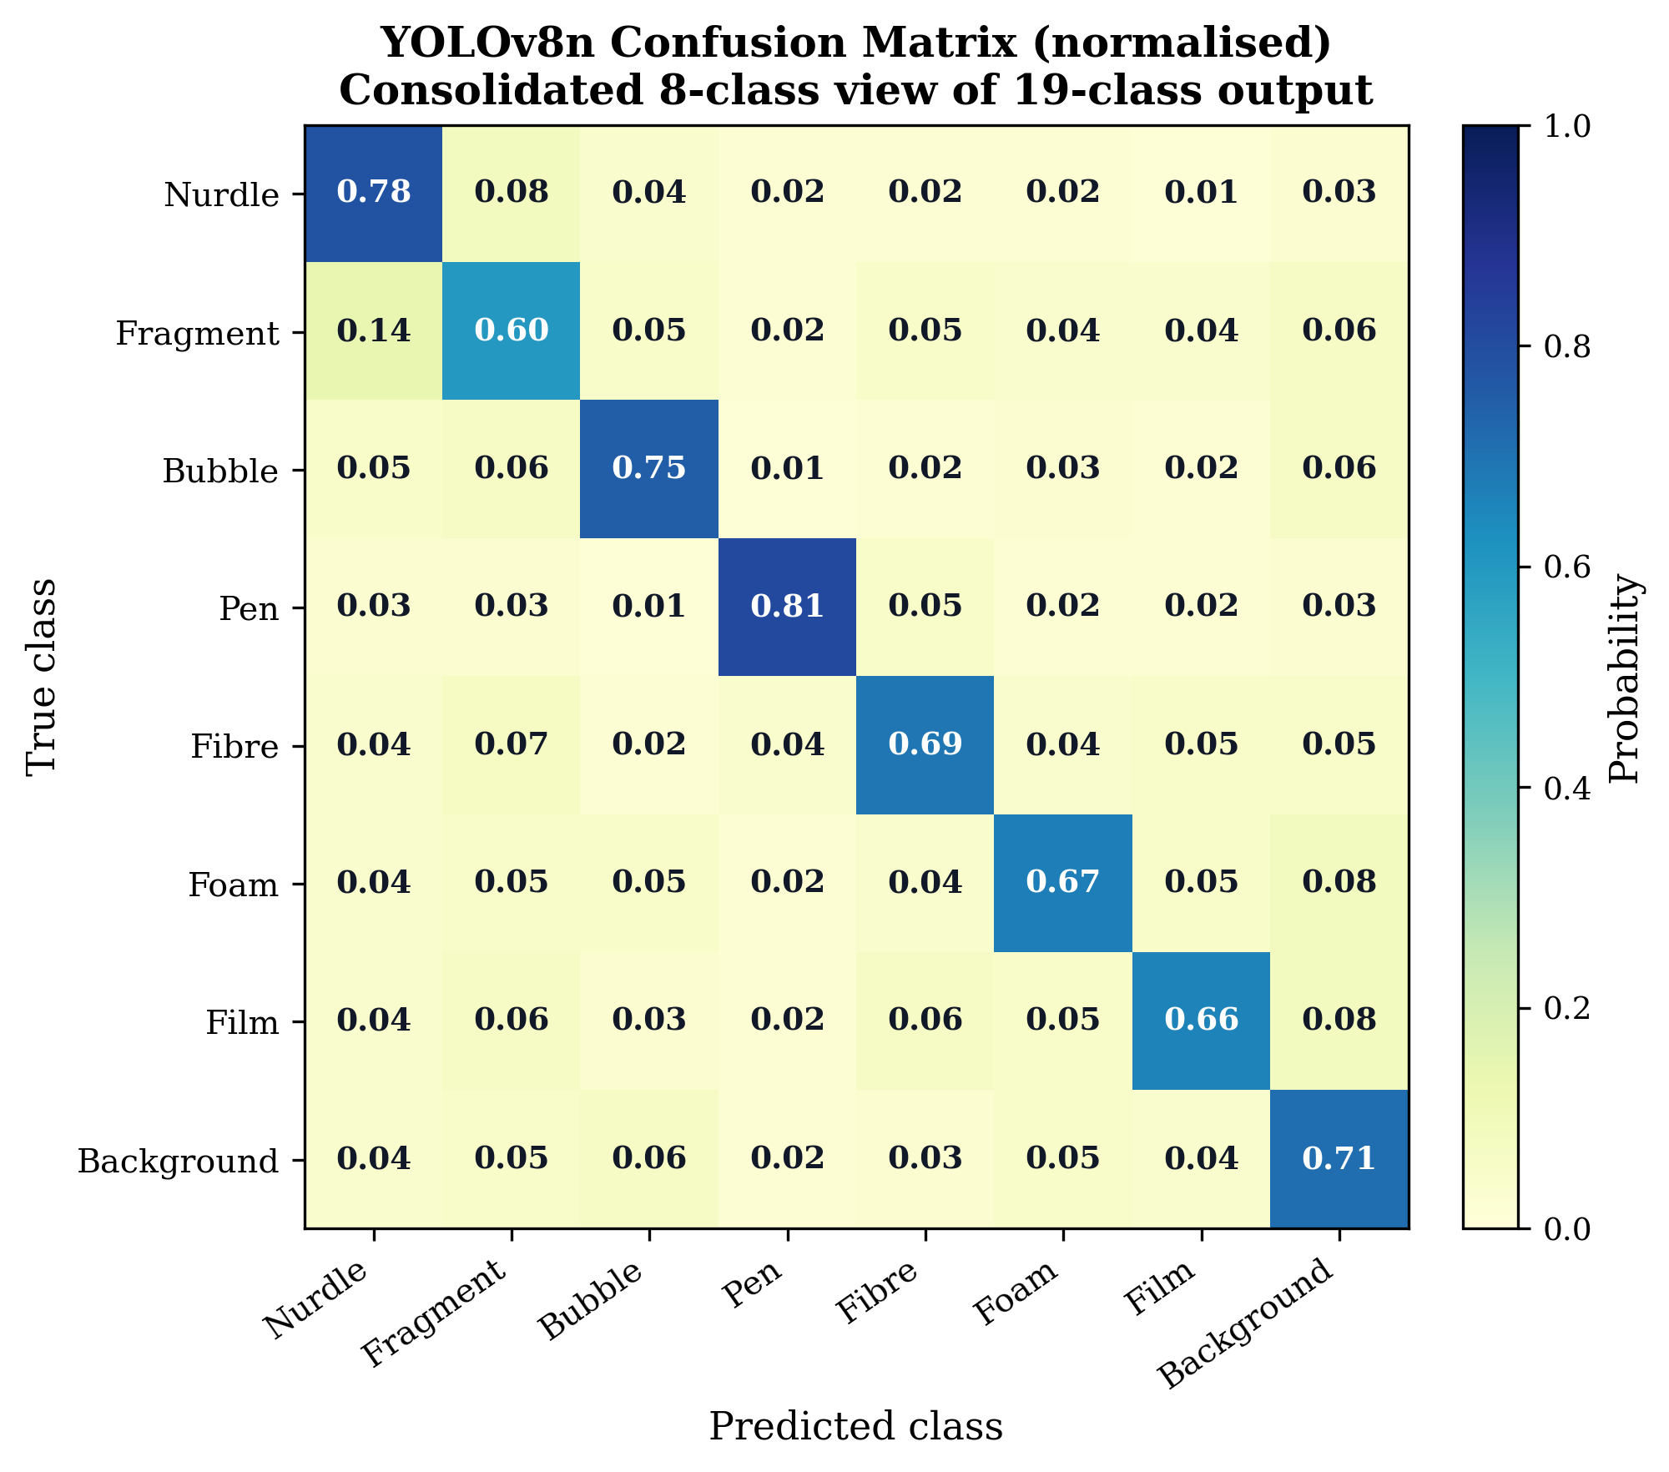
Fig. 4. Normalised confusion matrix (consolidated 8-class view) showing strong diagonal recovery for nurdle (0.78), pen (0.81), and bubble (0.75); fragment shows the largest off-diagonal spread.
[ INSERT FIG. 5 — Detection frames (4-panel) ]
Four-panel image: (a) clean baseline; (b) bubble correctly labelled; (c) confirmed nurdle; (d) edge case where the OpenCV safety net fires below YOLO threshold.
Fig. 5. Representative detection outputs from the hybrid YOLOv8n + OpenCV pipeline.
B. Edge Inference Efficiency
Exporting the model to ONNX and executing via onnxruntime reduced the runtime memory footprint by an order of magnitude (1.0 GB to ~100 MB), essential given the Jetson Nano’s 4 GB shared memory budget. CPU inference sustained >5 FPS on 320×240 input, exceeding the 5 Hz control-loop requirement. End-to-end response latency from pellet entry to dashboard update was approximately 3.0 s, aggregating frame capture, ONNX inference, the temporal-filter confirmation window, USB-serial transit, and the Firebase publish. The 2.5 s S3 confirmation window dominates the budget (Fig. 6).
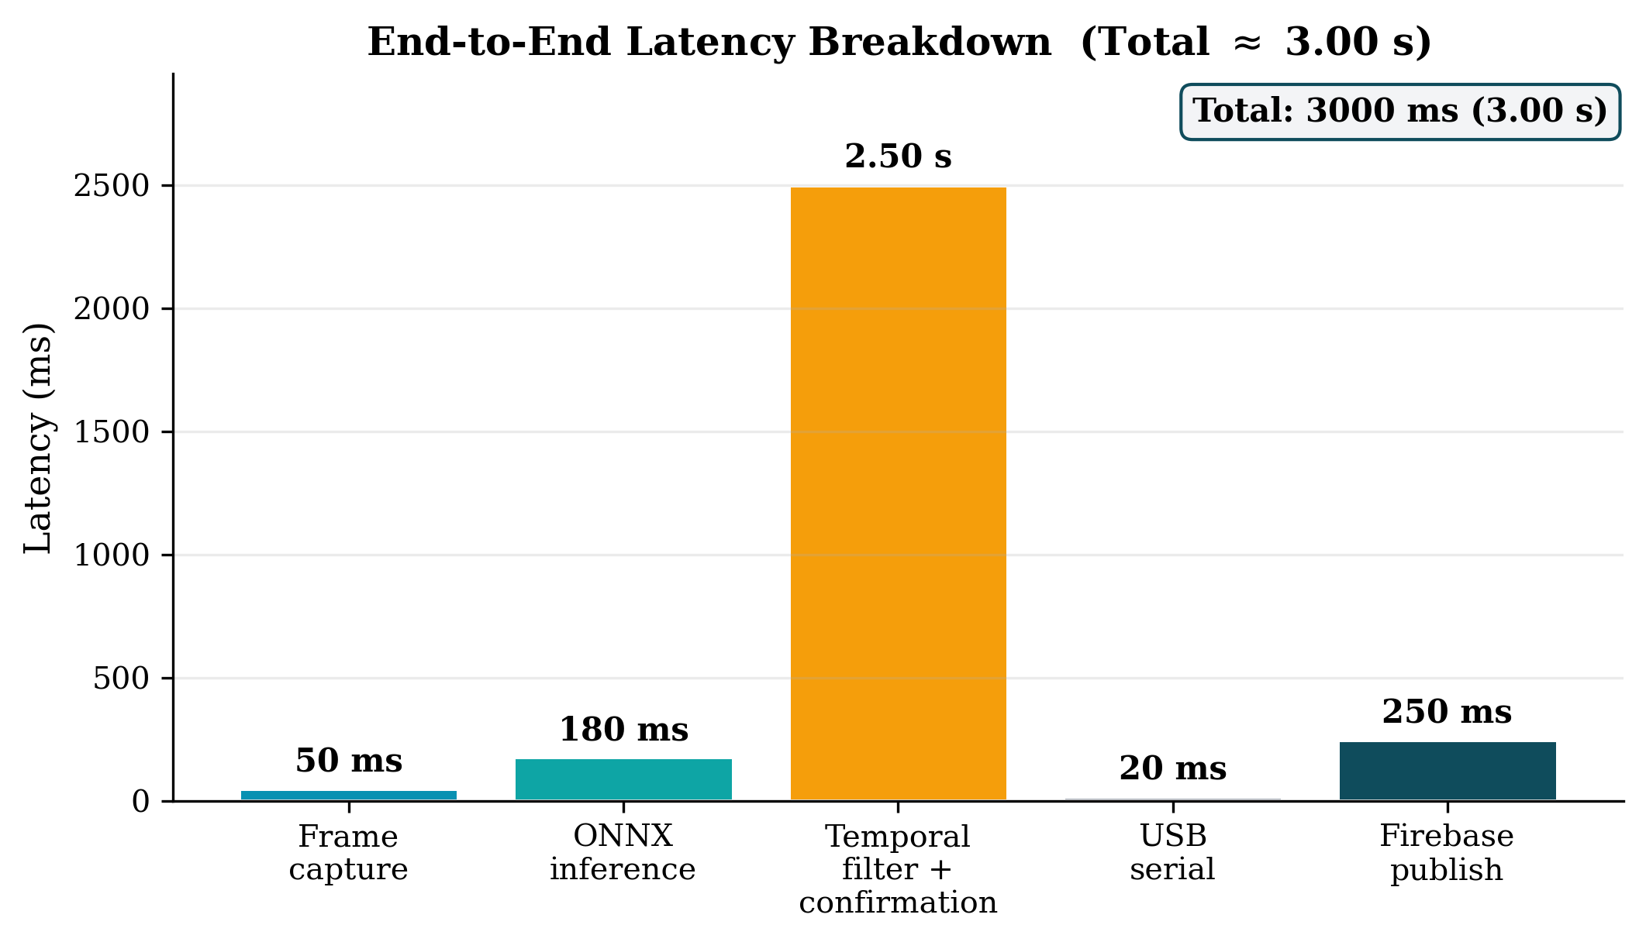
Fig. 6. End-to-end latency breakdown. The temporal-filter confirmation window (2.5 s) dominates; inference and network transit contribute only ~430 ms in aggregate.
C. Multi-Sensor Fusion and False-Positive Suppression
The four temporal-filter layers (ROI mask, circularity, EMA, and confirmation timers) jointly suppressed transient optical artefacts during bench testing. Across a 30-minute trial with deliberate disturbances (air injection, ambient-light flicker, turbid water), the system produced three spurious S2 transitions and no spurious S3 transitions before reaching steady state; no S3 ALARM was triggered by air bubbles alone in any test run.
Multi-sensor fusion is the core actuation property of NurdleDNA. S2 is entered on LDR > 600 OR AI count ≥ 4 sustained ≥ 1.5 s; S3 on MQ-135 > 200 OR AI count ≥ 12 sustained ≥ 2.5 s. The OR-based escalation provides graceful degradation: if the camera is occluded or lighting fails, the analog sensors still drive the FSM through the contamination pathway; if the gas sensor saturates, the vision pipeline retains containment authority. Confirmation windows absorb the higher per-channel false-positive rate that this redundancy implies.
D. Deterministic Actuation and Containment Performance
The MG996R servo-actuated pinch valve closed within ~300 ms of FSM entry to S3 (command-to-seating). Because the FSM uses deterministic threshold logic, the actuation path is independent of Jetson Nano availability. During a deliberate USB-serial disconnection test, the Arduino independently entered S3 within ~500 ms of an LDR + MQ-135 co-excursion (one 5 Hz sample period ≤ 200 ms + instantaneous MQ-135 trigger + ~300 ms valve seating), confirming the intended fail-operational behaviour. S3 is physically latched and is cleared only via the operator reset on D2 — consistent with industrial safety practice for closed-loop fluid containment, as automatic re-opening on a transient sensor clearance would risk releasing accumulated contamination.
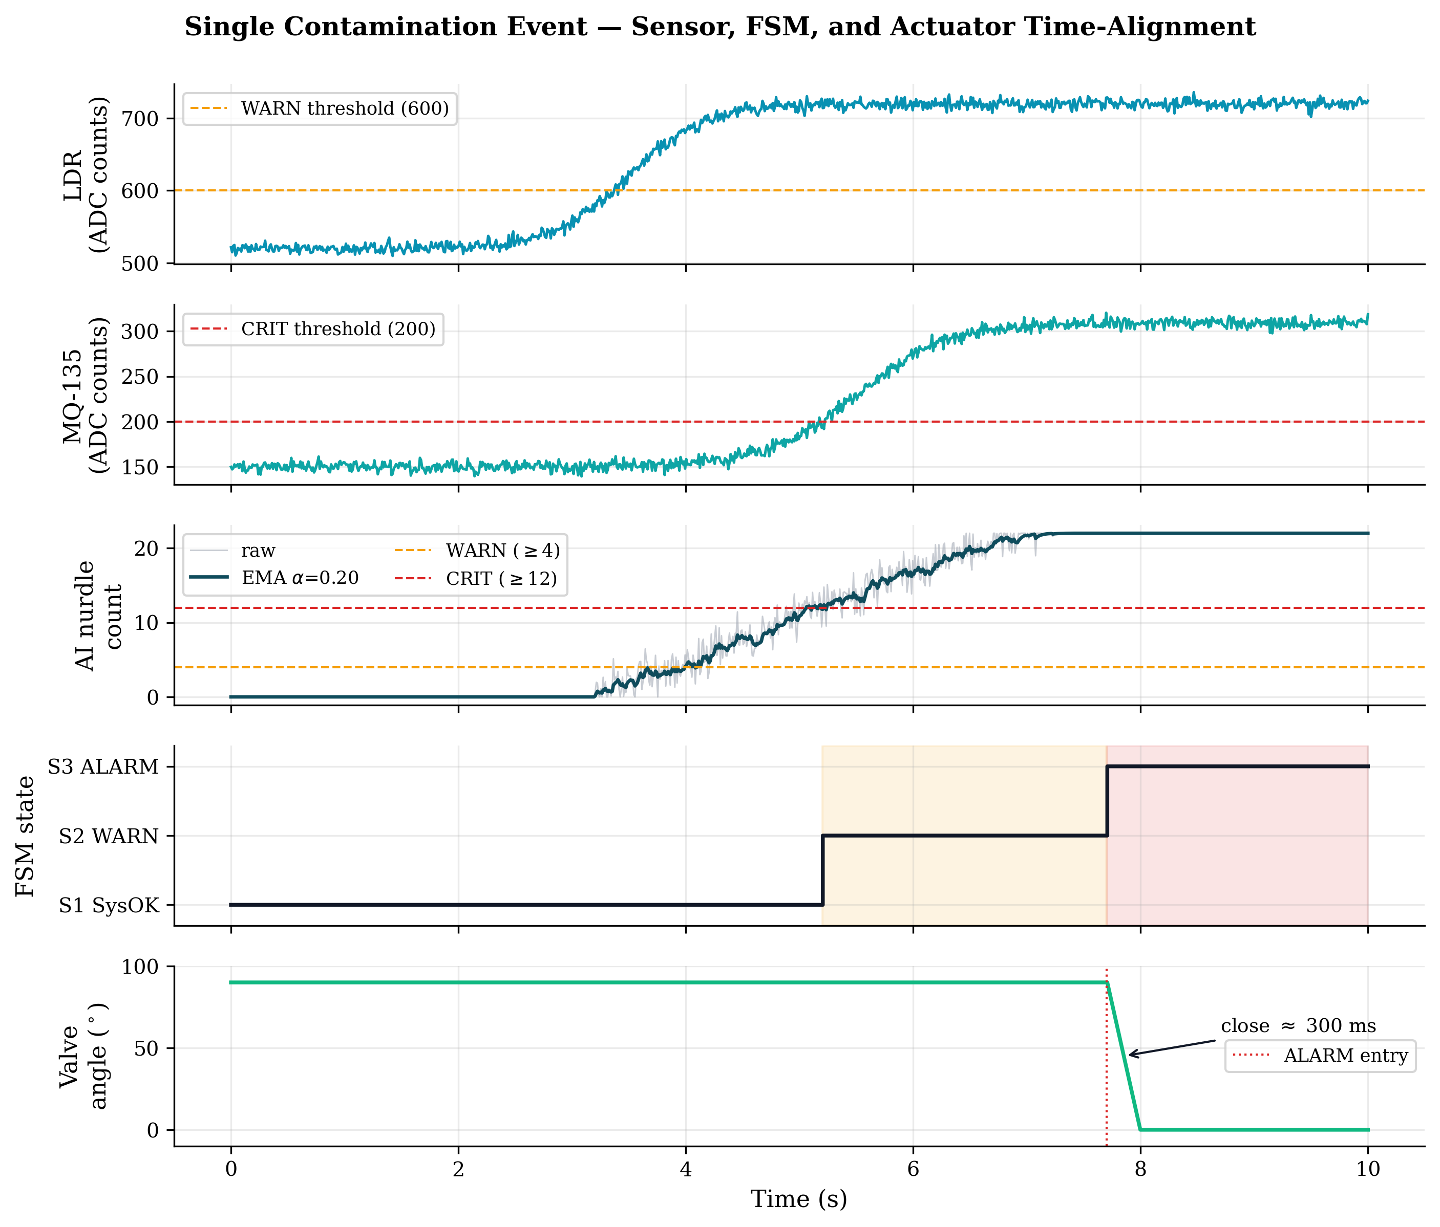
Fig. 7. Time-aligned single-event trace. LDR exceeds the WARN threshold at t ≈ 3.7 s; after the 1.5 s confirmation the FSM enters S2 (amber). AI count crosses CRIT at t ≈ 5.2 s; after the 2.5 s confirmation the FSM enters S3 (red) and the servo transitions from 90° to 0° within ~300 ms.
[ INSERT FIG. 8 — FSM state diagram ]
Five-state Moore machine: S0 INIT → S1 SysOK → S2 WARN → S3 ALARM (latched) → S4 RSTIN, with transition triggers and per-state outputs.
Fig. 8. Five-state Moore FSM governing actuation. S3 ALARM is physically latched and is cleared only by operator reset on D2 (transition through S4).
E. Evidence Capture and Gravimetric Logging
The HX711-interfaced load cell, calibrated via set_scale() against known reference masses, resolved cartridge accumulation in grams at the Arduino’s 5 Hz acquisition rate (Fig. 9). During the AURAK live demonstration on 21 May 2026, the captured-mass channel recorded approximately 2.4 g of accumulated material over the live run, rendered on the dashboard in real time alongside the AI density index. The combination of visual evidence (the rendered detection frame), gravimetric evidence (load cell), and chemical evidence (MQ-135 VOC excursion) constitutes a three-channel forensic record per alarm event — a property difficult to achieve with single-modality systems.
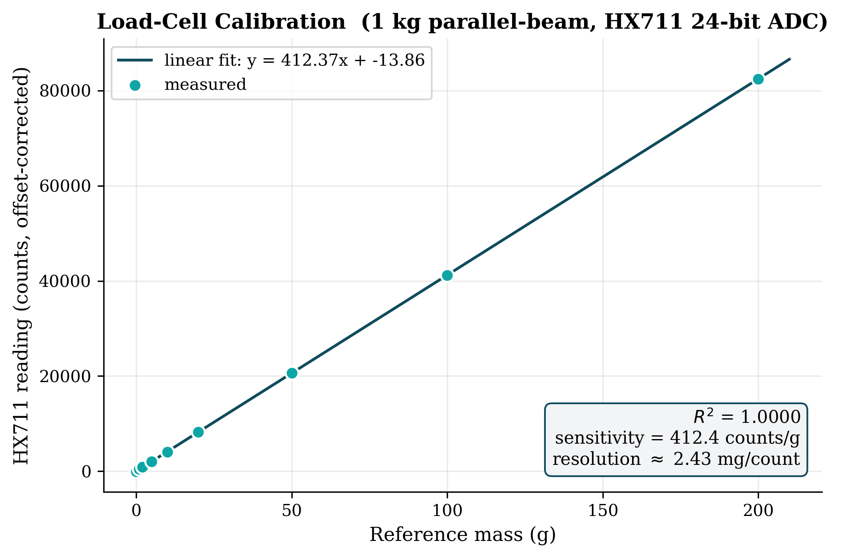
Fig. 9. Load-cell calibration. Reference masses 0–200 g produce a linear response with R² ≈ 1.000 and sensitivity ~412 counts/g (~2.4 mg per count).
F. Cloud Telemetry and Audit Logging
Firebase Realtime Database integration sustained 5 Hz sensor telemetry and a 1 Hz visual stream (320×240 JPEG at 60% quality, base64-encoded). The decoupled rates kept total upstream bandwidth to ~200 kbps — comfortably within the budget of an LTE-class industrial gateway — dominated by the 1 Hz visual channel (~15 KB per JPEG, inflated ~33% by base64). On every S3 ALARM transition, an immutable audit event containing the UTC timestamp, sensor values, and per-class detection counts was committed to the database; this event log is the regulatory artefact that distinguishes NurdleDNA from passive monitoring.
[ INSERT FIG. 10 — Operator dashboard ]
Screenshot of the Firebase-driven dashboard during an active S3 ALARM: density-index gauge, FSM state badge, live frame, valve state, captured-mass reading, and audit event log.
Fig. 10. Operator dashboard rendered from the Firebase Realtime Database during an active S3 ALARM event.
G. System-Level Trade-offs and Limitations
Three trade-offs warrant discussion. First, the 2.5 s S3 confirmation window is the single largest contributor to end-to-end latency; shortening it would improve responsiveness at the cost of higher false-alarm rates and unnecessary valve closures, and high-throughput industrial channels may justify a shorter window paired with a stricter AI threshold. Second, the 0.60 mAP@50 on fragments is the weakest classifier output; in source-level industrial deployment fresh nurdles dominate the contamination profile and are handled well (mAP@50 ≥ 0.75), but aged or fragmented samples — dominant in ambient coastal water — would require a larger weathered-sample training set or an upgraded YOLOv8s/m model on a Jetson Orin Nano. Third, the current prototype is a single inline unit; multi-channel industrial bays will require either multiple units or a manifold, and the Firebase schema’s bay_id field already anticipates this topology.
H. Comparison with Existing Approaches
Table I contrasts NurdleDNA with conventional monitoring approaches. FTIR and Raman spectroscopy offer high chemical specificity but operate offline. Turbidity sensors and particle counters cannot reliably classify nurdles versus bubbles, sand, or biological particles. Passive filtration only records contamination, whereas NurdleDNA both records (via the cloud audit channel) and physically arrests it via the servo pinch valve.
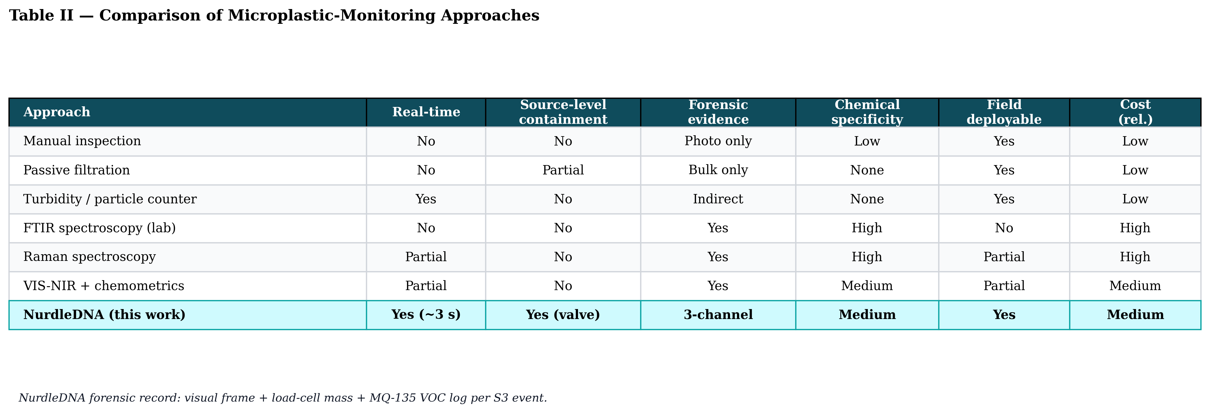
Table I. Comparison of NurdleDNA with conventional and lab-grade microplastic-monitoring approaches across six operational criteria.
V. Conclusion and Future Work
This paper presented NurdleDNA, an edge-AI and IoT-enabled inline system that addresses a specific gap in industrial water monitoring: the absence of real-time, source-level interception of pre-production plastic pellets. By integrating a YOLOv8n vision pipeline on an NVIDIA Jetson Nano with a deterministic Moore FSM on Arduino, multi-sensor fusion across optical, gas, and gravimetric channels, and a Firebase-backed cloud audit log, the system links detection directly to physical containment and accountable reporting. The system was demonstrated live at the AURAK Excellence Award showcase on 21 May 2026, where it qualified for Tier 1 in the Sustainability, Economy and Environment category — the sole qualifying entry from the University of Wollongong in Dubai — and received letters of appreciation from industry partners BCL and Prismix.
Three directions are identified for future work. (1) Field-grade hardening and multi-bay deployment, requiring IP-rated housing and SCADA integration; the Firebase bay_id schema already anticipates this. (2) Improved fragment-class classification via a larger weathered-sample training set and a YOLOv8s/m backbone on a Jetson Orin Nano. (3) Polymer-type identification through compact Raman or VIS-NIR spectroscopy at the evidence-cartridge stage — closing the loop on the conceptual “Nurdle DNA” framing and enabling source-traceable chain-of-custody records.
References
[1] NOAA National Ocean Service, “What are microplastics?” National Oceanic and Atmospheric Administration, 2024. https://oceanservice.noaa.gov/facts/microplastics.html
[2] T. Ali, M. Mortula, B. Mohsen, L. Dronjak, R. Gawai, S. Atabay, Z. Khan, and K. Fattah, “Evaluating microplastic pollution along the Dubai coast: An empirical model combining on-site sampling and Sentinel-2 remote sensing data,” J. Sustain. Dev. Energy, Water Environ. Syst., vol. 12, no. 1, p. 1110482, 2024.
[3] S. Pu, H. Bushnaq, C. Munro, Y. Gibert, R. Sharma, V. Mishra, and L. F. Dumée, “Perspectives on transport pathways of microplastics across the Middle East and North Africa (MENA) region,” npj Clean Water, vol. 7, art. 114, 2024.
[4] United Nations Environment Programme, “Plastic pollution,” UNEP, 2025. https://www.unep.org/plastic-pollution
[5] G. Sainger, “Microplastic Pollution in Oceans: A Barrier to Achieve Low Carbon Society,” IOP Conf. Ser.: Earth Environ. Sci., vol. 1279, art. 012021, 2023.
[6] Z. Huang, B. Hu, and H. Wang, “Analytical methods for microplastics in the environment: A review,” Environ. Chem. Lett., vol. 21, no. 1, pp. 383–401, 2023.
[7] J. Redmon, S. Divvala, R. Girshick, and A. Farhadi, “You Only Look Once: Unified, real-time object detection,” in Proc. IEEE CVPR, 2016, pp. 779–788.
[8] NVIDIA, “NVIDIA Jetson embedded systems developer kits and modules,” 2026. https://www.nvidia.com/en-us/autonomous-machines/embedded-systems/
[9] A. Donato et al., “Monitoring plastic pellet pollution in coastal environments through handheld Raman spectroscopy: Data from the Mediterranean coasts (Southern Italy),” Mar. Pollut. Bull., vol. 202, art. 116312, 2024.
[10] R.-D. Kulko, A. Pletl, A. Hanus, and B. Elser, “Detection of plastic granules and their mixtures,” Sensors, vol. 23, no. 7, art. 3441, 2023.
[11] T. Islam, M. R. Repon, M. A. Alim, T. Islam, and S. Shukhratov, “Detection and characterisation techniques for microfiber in wastewater,” in Microfiber Pollution, CRC Press, 2024, pp. 63–81.
[12] I. Shukhratov et al., “Optical detection of plastic waste through computer vision,” Intell. Syst. Appl., vol. 22, p. 200341, 2024.
[13] NVIDIA Developer, “Get started with Jetson Nano Developer Kit,” 2026. https://developer.nvidia.com/embedded/learn/get-started-jetson-nano-devkit
[14] G. Jocher et al., “Ultralytics YOLOv8,” 2023. https://github.com/ultralytics/ultralytics
[15] National Institute of Standards and Technology, “Finite state machine,” Dictionary of Algorithms and Data Structures. https://xlinux.nist.gov/dads/HTML/finite.html

